Diagrams for architecture

Borrow My Books

# Activities:

## Login

C:\development\BorrowMyBooks\Documents\Diagrams\BorrowMyBooksLoginActivityDraw.io.png

## Signup

C:\development\BorrowMyBooks\Documents\Diagrams\BorrowMyBooksSignupActivityDraw.io.png

## Upload Book

C:\development\BorrowMyBooks\Documents\Diagrams\BorrowMyBooksUploadBookActivityDraw.png

# Database

C:\development\BorrowMyBooks\Documents\Diagrams\BorrowMyBooks Data Model Class Diagram v1.2.png

# High Level Overview of Live Site

C:\development\BorrowMyBooks\Documents\Diagrams\BorrowMyBooksHighLevelDiagramDraw.png

# Module (code) dependencies from app.js (core component of the server)

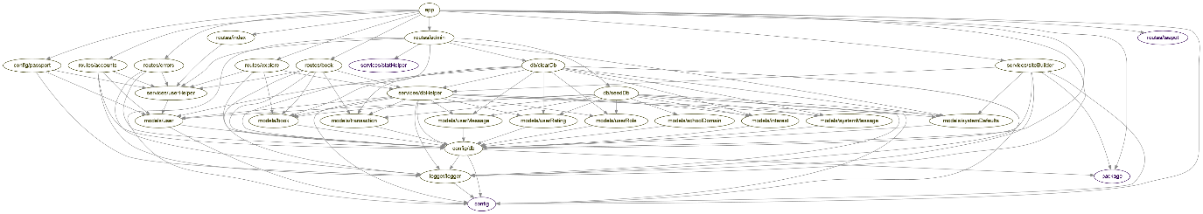

# Coverage and Testing Report

